PROFIT: Jurnal Administrasi Bisnis
Vol. 17. No. 1, 2023
e ISSN: 2338-4654
p ISSN: 1978-743 X
https://profit.ub.ac.id

Title
Title should not be more than 14 words; Title should be clear and precise
(14 pt, Times New Roman, bold, Paper A4)

Author 1*, Author 2 (11pt, Times New Roman, no title, bold)
Affiliation 1, Affiliation 2 (11pt, Times New Roman)
Email 1, Email 2

ABSTRACT

Abstract should consist of aim(s) of the study, research methods, and a summary of the result and discussion. No reference is allowed on the abstract.
(Times New Roman, 11pt, italic and not more than 250 words)

Keywords:(11pt, Times New Roman, bold) not more than 5 words

ABSTRAK

Abstract dalam Bahasa indonesia

Kata Kunci: (11pt, Times New Roman, bold) tidak lebih dari 5 kata

*Corresponding author

1. INTRODUCTION (11pt, Times New Roman, Bold)
1 cm
This chapter explores about:
a. The research problems and research questions
b. significance of the study and its purposes
c. Novelty
d. Research gap
(11pt, Times new roman)

2. LITERATURE REVIEW (11pt, Times New Roman, Bold)
This Chapter elaborates clearly about:
a. Theory
b. Review from previous studies
c. Hypothesis development (if applicable)
(11pt, Times new roman)

3. RESEARCH METHOD (11pt, Times New Roman, bold)
This chapter contains the methods that has been used completely and clearly, including how they collect and analyse the data.
(11pt, Times new roman)

4. RESULT (11pt, Times New Roman, bold)
This chapter contains the result of the study and results should be clear and concise. Table, chart, figure and graphs illustrating the results are typically included.
(11pt, Times new roman)

5. DISCUSSION (11pt, Times New Roman, bold)
This chapter elaborates a discussion derived from the result chapter before, accompanied by theories and previous studies. The author should not repeat the result chapter, but have to explain the findings and analysis based on the result. The author also has to explore the significance of the results of the work.
(11pt, Times new roman)

6.CONCLUSION AND RECOMMENDATION (11pt, Times New Roman, bold)
Conclusions
This chapter explain the conclusions obtains from this study as well as the implication of the study.
Recommendations
This chapter explain the recommendation / suggestion for the further study, body of knowledge and business practice.
(11pt, Times new roman)

REFERENCES (11pt, Times New Roman, Bold)
- Use a reference application, Mendeley with APA 7th style.
- It should consist of at least 60% materials / references that are published in the last 10 years
- The paper should cite at least 2 papers from PROFIT from previous editions.

NOTES:
- Author might add CHAPTER other than those listed above if needed.
- Author might add sub chapter (11pt, Times new roman, italic, bold)
- Maximum 15 pages
- How to put table and figure on the article:
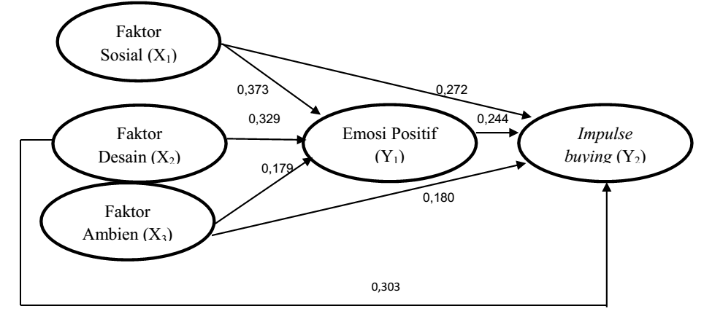
Figure 1. Hypothesis Development Model (10 pt, Times New Roman, bold)
Source: Author, Year
Table 1
Descriptive Statistic
(10 pt, Times New Roman, bold)
Variable | Total | MIN | MAX
TRR | 134 | -2,4602 | 636,4244
BPT | 134 | ,0000 | 25,1111
Profit | 134 | 0 | 1
Source: Author, Year

Writing Systematic Standard

A Research Paper | A Review Paper
- Introduction | - Introduction
- Literature Review | - Literature Review
- Research Method | - Discussion
- Result | - Conclusion and recommendation
- Discussion
- Conclusion and recommendation

